**Rhythm Defense**



# Quick Links

# 

SCRUM

Includes WBS

<https://docs.google.com/spreadsheets/d/1EhkoN2dkBaLs-Dqjcp0LMA9vMw9wRT1DBy32i0G3ghw/edit#gid=0>

TRELLO

<https://trello.com/b/ERDHglTq/bard-td-ue4>

DISCORD

<https://discord.gg/x64HPqQ>

# 

# 

# Overview

## Theme

* + Rhythm
  + Tower Defense

## Targeted platforms

* + PC

## Monetization model (Brief/Document)

* + Monetization Type -- none (currently)

## Project Scope

* + OCT. 19 - MAY 5, 2021
    - Cost -- zero to low
  + Team Size - 2
    - <Core Team>
      * Troy Andrews
        + Project Manager, Lead Designer, Programmer
      * Scott Rivett
        + Lead Programmer, Designer
      * Andy Tu
        + Lead Artist, Designer, Designer
      * Aidan Loewen-Thomas
        + Lead Sound, Designer

## Influences (Brief)

* + WarCraft 3 TD games
  + Rhythm games

## The Elevator Pitch

Cyberpunk genre stylistic game. A rhythm style tower defense game where players must create barricades and defenses against invaders using a specific order of keys to cast spells and craft builds. **(More to come once fleshed out)**

## 

## Project Description (Brief)

<Two-Three paragraph description>

## Project Description (Detailed)

<Four-Six paragraph project description>

# 

## Lane (path) Mechanism

* + Details -- There are multiple separate lanes to the center of the map. Each lane has its own unique features aligned to it (see below).   
    (IMAGE GOES HERE)  
      
    Entities spawn and move to each segment (block) of the lane and funnel out into the fog until the current segment is out of resource (life).   
    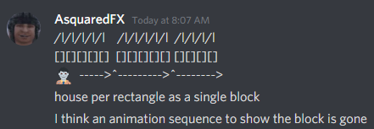  
    As shown above, each segment harbors X buildings which can be used to build automated “turrets” (see Buildings (continued)) which will be permanently destroyed upon loss of that segment.  
      
    When a segment is lost, all buildings are destroyed and no resources are refunded. This forces players to make strategic decisions on placement *(review this later for potential pillage refund mechanics in talent tree)*.  
      
    Each segment returns an income amount (Metal) to the player at the end of each wave. Each segment can generate extra Metaland be upgraded to increase the base amount.  
      
    Once all segments are dead, enemies still spawn in that lane but travel to the end point (Essence Crystal). When the crystal depletes, you lose.
* **Lane (features) Path**
  + Details -- Each lane has a unique set of characteristics that has a direct effect on how enemies, spells, and buildings interact with it. We call these lane characteristics -- *features*.
  + Every Lane Gets the following *features*
    - Certain areas cannot be built on. They are either blocked or have been destroyed, or natural inconvenience (puddle).
    - Spells cannot be casted in certain areas (perhaps building canopies or bridges?)

**Lane 1**

Image of lane design

* SPECIAL FEATURE -- Shape

**Lane 2**

Image of lane design

* SPECIAL FEATURE -- Shape

**Lane 3**

Image of lane design

* SPECIAL FEATURE -- Shape

## Multiplayer System

* + Details -- Each player is given a separate lane, lifepool, income, essence bar, and so on. Connections are based on P2P (no server).

## Sabotage (“fuck over system”)

* + Details -- Sabotage people on your team!

## Enemies

* + Details -- Enemies spawn at the beginning of each lane and progress through to the end of each segment. Once the enemy has reached the end of the segment, they are directed off screen into fog or an alleyway. Enemies attack any blockades in front of them and will attempt to find the path of least resistance.
* **Types**
  + Normal
    - Details -- your typical enemy. (Husks aka “essence seekers”)
    - Attributes -- enemies spawn with a randomized immunity or attributes assigned to them upon spawning. *Each enemy with a special effect will be colorized, have an over-head indicator or a different model.*
      * Reclaimed (NATURE) -- reduced damage from physical AND...
        + Aleatoric Tornado
        + Tenor Takedown
        + Natural Nonet
      * Charred (FIRE) -- moves quickly AND...
        + Fortissimo Fire
      * Unstable (ARCANE) -- explodes on impact AND…
        + Deafening Sforzando
        + Melodic Melancholy
      * Others.

## Core Gameplay Mechanics (Detailed)

## Essence Bar

*70/100 essence remaining*



* + Rhythm Essence (mana)
    - Details -- The main mana pool is called Rhythm Essence. It begins at 100% and is only regenerated by killing enemies or at the beginning of the next round.
    - How it works -- Each spell requires essence to complete. The amount each spell costs as well as how much is regenerated (passively) depends on your skill choices (SEE TALENT SYSTEM).   
        
      This forces players to make decisions with spells, as well as preventing players from spamming identical spells. This system paired with a skill combination system (oil+fire, for example) will give players more control over their gameplay.

## Resources (Metal)

* + Metal System
    - Details -- Metal is the main resource used to build destructibles and upgrade buildings. Metal is gained through income *only*.
      * Income -- Earned through each segment. Segments can be upgraded to produce more Metal.
  + Cost List

| **Buildings (per sq.)** | **Cost (**Metal**)** |
| --- | --- |
| Rock Throw | 20 |
| Spill Oil | 20 |
| Farm/Metal Land | 20 |
|  |  |
| **Destructibles** |  |
| Metal Spikes | 5 |
| Metal Wall | 4 |

## Spells

## Spell System

* + - Sound -- **All spells follow the background music.**
    - Details -- Players use QWER to input a sequence of characters in a specified order, in order to cast a spell. All spells have a base mana cost that siphons directly from the main essence pool.
    - How it works -- The spell menu is opened by pressing (Q) and has up to 5 key combinations to match (I.E. WEQWQ). Spells are auto-populated if available, so if a player starts with W, every spell starting with W will be available. Spells automatically cast on cursor. Further mechanics can alter this cursor effect, such as spells that require click and dragging the mouse, hovering, or even basic cursor mouse-over (SEE LIST OF SPELLS).
    - **Once activated** -- A short spell timer will appear on screen (probably a circular bar around the cursor that changes colors -- green full/red empty). If the player hits the wrong key or misses the time window, the spell fails.
      * **ALL NOTES MUST BE IN KEY TO EACH SPECIFIC LEVEL SONG.**
  + PUT THIS AT THE BOTTOM WITH THE SPELL SYSTEM.
    - Add basic imagery, spell name, keys, description, and cost.
    - -- need to add 10 spells starting out --
    - **Natural Nonet** (long cd, trap that you set, when x amount of enemies enter the area -- the trap activates and roots them, select an area)
    - Meteor (long cd, shoots meteors for the sky, shoots behind camera, select area)
    - Icewall (use as force block entities or a maze, draw with mouse)

### Melodic Melancholy

Type -- Sound

Mechanic Type -- Trap

Cooldown -- 10s

Input -- qqqqq

Description

Sleeps X closest targets for (Xs). Damage will wake the target dealing extra (Xd) and slow

them for (X%) for (Xs).

How it works

Select a location to set your trap (must be on navmesh).

Cast the spell then play a series of inputs until you either fail, or reach X (max).

To release the spell, select the trap and set it to “active”. Traps automatically

start in “passive mode”.

Example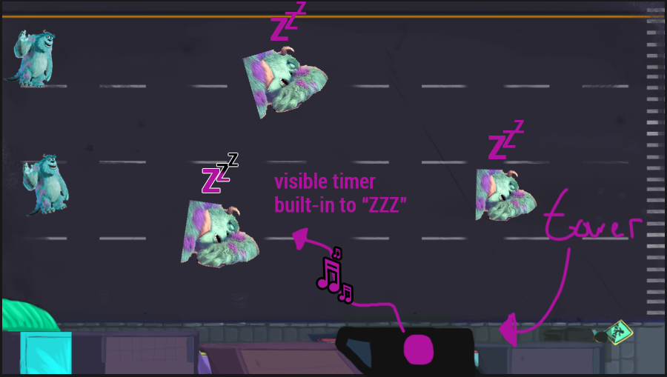

### 

### 

### Fortissimo Fire

Type -- Fire

Mechanic Type -- Realtime

Cooldown -- 2s

Input -- qqqqq

Description

Sets fire to any target for (Xd) over (Xs) after passing through it.

How it works

Cast the spell from your menu and select a start location. As the player moves their mouse, inputs will appear on the cursor location which must be inputted before passing the threshold into the next input, or the time runs out. The faster the movement of the mouse, the faster the inputs. If a player exceeds the current input they will fail the cast and it will stop where the last successful input was entered. There is a maximum of X inputs allowed when casting, and overlapping the spell does not matter because the fire damage is a damage over time spell.

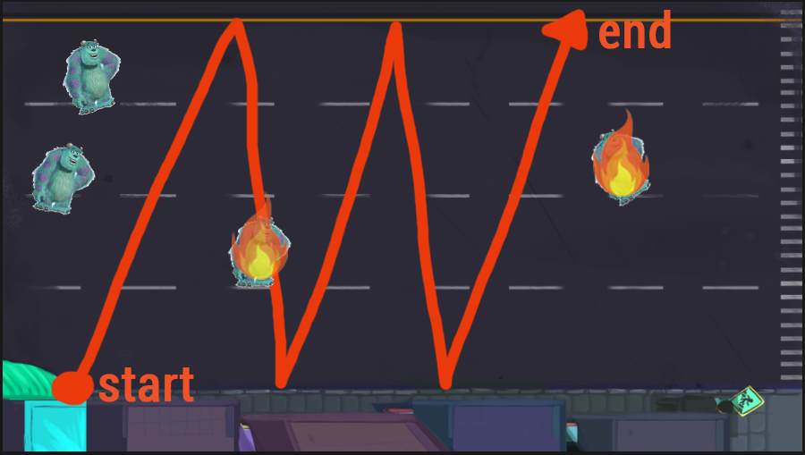

### 

### Tenor Takedown

Type -- Nature

Mechanic Type -- Realtime

Cooldown -- 10s

Input -- qqqqq

Description

Shockwaves the ground for (Xd) for each successful input and slows all enemies inside for (X%).

How it works

Cast the spell from your menu and select an acceptable location on the navmesh. Once completed, the player has X amount of time (short duration) to complete a two-key input (QWER). Each successful input continues the spell and unleashes 1 shockwave to deal damage. The slow is persistent throughout the cast; however, each input deals damage and continues the duration of the main spell. Upon each successful input the duration between failures is reduced. So, from 1 second to .9, .8, .7 … .1 seconds to cast. No two keys can be the same, so Q+R is acceptable -- but Q+Q is not.

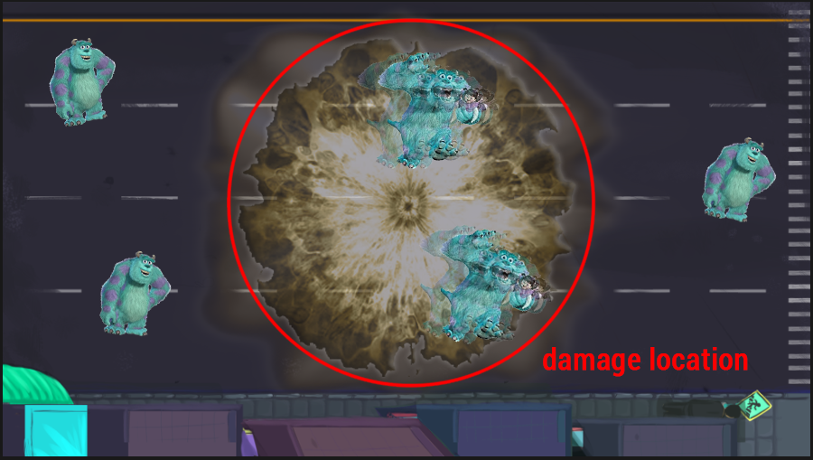

### Aleatoric Tornado

Type -- Nature

Mechanic Type -- Realtime

Cooldown -- 25s

Input -- qqqqq

Description

Summon a tornado that passes through elements and gains their effects (fire, ice, etc.) and has a(n) (X%) chance to knock up and stun enemies and deal (Xd).

How it works

Player casts the spell, draws a beginning and end location, and accepts by pressing “H” (or any other key, maybe even the same input) in order to begin the tornado spell. The camera will lock onto the tornado coordinates and a rhythm-type game will begin.

Rhythm Game (Tornado)

I DON’T KNOW I HAVEN’T THOUGHT ABOUT IT. COPY OSU?

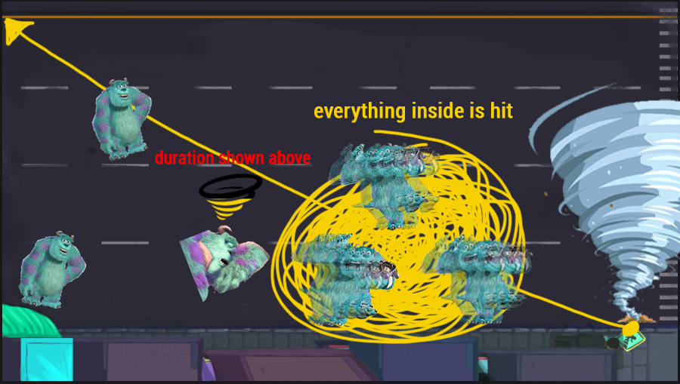

* + - **Deafening Sforzando** ((ask mark later) deafens all entities on the map)
    - **The Magnum Opus** (big ol dookie momma spell that slams, uses everything idk it’s funny)

## Destructibles

* + Destructible System
    - Details -- The destructible system works similar to spells. The Bard creates buildings and places them by casting using a sequence of keys. The difference is, buildings are permanent (destructible) entities.
    - How it works -- Cast a building like a spell (see Spells) and simply choose the location or area for your building type. Buildings cost a separate resource which (gold?) which is gained as income and from defeating magic-seekers.
  + Types
    - Wooden Spikes (deals damage when walked by or attacked, loses durability each time, place and rotate)
    - Basic wooden wall (rotates, does nothing except builds a path)

## Buildings

* + Build System
    - Details -- As discussed earlier, each segment harbors up to *X* buildings that can be upgraded to use certain abilities. Each tower upgrade costs *X* resources in order to purchase, and can be upgraded.
  + Types
    - Throw Rocks -- a simple upgrade that allows the building to throw rocks at nearby targets.
    - Spill Oil -- dump oil from windows at (target location or single target) and has a small chance to stun the enemy; can also be combined with fire spells to burn longer.
    - Mine -- increases Metal production from this segment. Increases Metal income by X.
  + Research System
    - <Details> /Describe in 2 Paragraphs or less/
    - <How it works> /Describe in 2 Paragraphs or less/
  + Talent System
    - <Details> The talent system changes how both spells and buildings function. It adds modifiers and the ability to combine certain spell effects together.
    - <How it works> /Describe in 2 Paragraphs or less/

# Story and Gameplay

## Story (Brief)

* + The city of Rhythmamia is under invasion by a hive-mind like set of creatures. They are only interested in the center focal point of the map which is the Rhythmamians crystal which contains all of the magic essence in Rhythmamia. These magic-seekers are only interested in siphoning the crystal for its power, which largely protects the town from the destructive outside world. The town has gone into lockdown, but the Rhythm-ers of Rhythmamia have decided to defend the town. With the help of some of the townspeople and other Rhythm-ers, you must defend the crystal at all costs.

## Story (Detailed)

* + /Go into as much detail as needs be/
  + /Spare no detail/
  + /Use Mind Mapping software to get your point across/

## Gameplay (Brief)

* + <The Summary version of below>

## Gameplay (Detailed)

* + /Go into as much detail as needs be/
  + /Spare no detail/
  + /Combine this with the game mechanics section above/